A
PROJECT REPORT
(PS04CSTA54)
ON

“STATISTICAL ANALYSIS OF ROAD ACCIDENTS IN INDIA: TRENDS, SEVERITY, CONTRIBUTING FACTORS AND FORECASTING”
A
PROJECT REPORT
SUBMITTED IN PARTIAL
FULFILMENT OF THE REQUIREMENTS
FOR THE AWARD OF THE DEGREE OF
M.Sc. Statistics

SUBMITTED BY
VAISHNAV SANJAY PAWAR (21)
PRANSHUL GOKUL PATIL(14)

UNDER THE GUIDANCE OF
Prof. (Dr.) Jyoti M. Divecha
DEPARTMENT OF STATISTICS
SARDAR PATEL UNIVERSITY
VALLABH VIDYANAGER, ANAND – 388120
GUJARAT (INDIA)

April-2026



A
PROJECT REPORT
(PS04CAST55)
ON

“STATISTICAL ANALYSIS OF ROAD ACCIDENTS IN INDIA: TRENDS, SEVERITY, CONTRIBUTING FACTORS AND FORECASTING”
A
project report
submitted in partial
fulfilment of the requirements
for the award of the degree of
M.Sc. in Statistics

SUBMITTED BY
VAISHNAV SANJAY PAWAR(21)
PRANSHUL GOKUL PATIL(14)

UNDER THE GUIDANCE OF
Prof.(Dr.) Jyoti M.Divecha
DEPARTMENT OF STATISTICS
SARDAR PATEL UNIVERSITY
VALLABH VIDYANAGER, ANAND – 388120
GUJARAT (INDIA)

April-2026

CERTIFICATE

This is to certify that Mr. Vaishnav Sanjay Pawar, Roll No. 21 student of Master of Science in Statistics, has satisfactorily completed his project work on “STATISTICAL ANALYSIS OF ROAD ACCIDENTS IN INDIA: TRENDS, SEVERITY, CONTRIBUTING FACTORS AND FORECASTING” under the Paper Project Work (PS04CSTA54) for M.Sc. Statistics Semester IV during the period Nov 2025 – April 2026.

Place: Department of Statistics, V.V Nagar, Anand
Date: 11th April 2026

Prof.(Dr.) Jyoti M. Divecha. Dr. Dharmesh Raykundaliya
(Project Guide) (Head of Department)

DECLARATION

I hereby declare that the report entitled “STATISTICAL ANALYSIS OF ROAD ACCIDENTS IN INDIA: TRENDS, SEVERITY, CONTRIBUTING FACTORS AND FORECASTING” is an original work Prof.(Dr.) Jyoti M.Divecha. This work has not been submitted, either in full or in part, to this or any other University for the award of any degree, diploma, or any other academic qualification.
I further declare that all the sources of information used in this study have been properly acknowledged.
Place: Department of Statistics, V.V Nagar, Anand
Date: 11th April 2026

Signature
Vaishnav Sanjay Pawar

ACKNOWLEDGEMENT

I would like to express my sincere gratitude to my project guide, Prof.(Dr.) Jyoti M.Divecha, for his valuable guidance, continuous support, and insightful suggestions throughout the course of this project. His mentorship has been instrumental in the successful completion of this work.
I am highly thankful to Prof. Dr. Dharmesh P. Raykundaliya, Head of the Department, Department of Statistics, Sardar Patel University, for providing the necessary academic environment and encouragement to carry out this study.
I would also like to extend my sincere thanks to Prof. Dr. Jyoti M. Divecha, Dr. Khimaya Tinani, and Mr. Mahesh Bhingikar for their guidance in helping me understand and effectively apply statistical and machine learning techniques in real-life contexts. I am equally grateful to Ms. Mansi M. Balva and Ms. Kalyani Patil for their constant support and encouragement throughout this work.
I am also thankful to my classmates for their valuable discussions, support, and collaborative learning, which contributed to the successful completion of this project. I would also like to acknowledge the non-teaching staff of the department for their assistance and cooperation.
Finally, I express my grateful gratitude to my family for their unwavering support, encouragement, and understanding, which have been a constant source of strength throughout this journey.

Vaishnav Sanjay Pawar
Place: Dept. of Statistics, V.V Nagar, Anand
Date: 11th April 2026
TABLE OF CONTENT
Sr. No | Topic | Page No.
1. | Introduction | 1
2. | Literature Review | 6
3. | Dataset and Variable Description | 10
3.1 | Data Overview | 12
4. | Methodology  4.1 Exploratory Data Analysis (EDA)  4.2 Growth Rate Analysis  4.3 Severity Rate Analysis  4.4 Survival Rate Analysis  4.5 Poisson Regression Model  4.6 Negative Binomial Regression Model  4.7 Overspeeding Model (NB Model)  4.8 Augmented Dickey-Fuller (ADF) Test  4.9 Time Series Analysis (Holt’s Model)  4.10 Two-Sample t-Test  4.11 Wilcoxon Rank Sum Test | 14

Sr. No | Topic | Page No.
5. | Results and Interpretation  5.1 Trend Analysis of Road Accidents  5.2 Growth Rate Analysis  5.3 Severity and Survival Analysis  5.4 Impact of Over speeding  5.5 Over speeding Model Results  5.6 Effect of Road Type (Poisson & NB)  5.7 Hypothesis Testing (t-Test & Wilcoxon)  5.8 Time Series Forecasting | 30
6. | Conclusion & Recommendation | 68
7. | Reference | 72
8. | Appendix | 75

LIST OF FIGURES

Figure 5.1 Trend of Road Accidents And Fatalities in India (2005-2023)
Figure 5.2 Survival rate
Figure 5.3 Over Speeding
Figure 5.4 Percentage of total accident due to over speeding
Figure 5.5 Histogram (State- Tamil Nadu)
Figure 5.6 Histogram (State- Gujarat)
Figure 5.7 Box Plot (Tamil Nadu vs Gujrat)
Figure 5.8 Histogram (State- Karnataka)
Figure 5.9 Histogram (State- Gujarat)
Figure 5.10 Box Plot (Gujrat vs Karnataka)
Figure 5.11 Forecasting Plot

LIST OF TABLES

3.1 The key variables used in this study
5.1 State Wise Total Accidents
5.2 State Wise Total Killed
5.3 State wise Total Injured
5.4 Growth rate for accidents injured killed
5.5 Severity (Death per 100 Crash)
5.6 Model comparison (Road type)
5.7 Model coefficient and interpretation (Road type)
5.8 Model coefficient and interpretation (Road type)
5.9 Forecasting From 2024 to 2028

ABSTRACT
This study analyzes road accident patterns in India using data from 2005 to 2023 obtained from official government reports. The objective is to examine trends, identify key contributing factors, and apply appropriate statistical models for analysis and forecasting.
The results indicate that although total accidents fluctuate over time, fatalities have increased, suggesting rising accident severity. Overspeeding is identified as the primary cause, contributing to nearly 70–72% of total accidents. Road-type analysis shows that straight roads are associated with higher accident counts due to greater speed and traffic exposure.
Poisson regression was initially applied but found unsuitable due to overdispersion. The Negative Binomial model provided a better fit and confirmed significant effects of road characteristics. Time series analysis using Holt’s model indicates a gradual increase in accidents in the coming years.
The study highlights the need for effective speed control, improved road safety measures, and data-driven policy interventions to reduce accident risk and fatalities.

1. INTRODUCTION

1.1 Background of the Study
Road accidents are a major public health and safety concern in India. With rapid urbanization, population growth, and increasing number of vehicles, traffic density has risen significantly, leading to a higher risk of road accidents.
Every year, a large number of people lose their lives or suffer injuries due to road accidents. These accidents not only cause human loss but also result in economic burden, including medical costs, loss of productivity, and social impact on families.
Among various causes, overspeeding has emerged as the leading factor, contributing to a majority of accidents and fatalities. In addition, road characteristics such as straight roads, curves, and road conditions also influence accident occurrence. Interestingly, straight roads often show higher accident rates due to higher vehicle speeds.
Despite the implementation of traffic rules and safety measures, accident severity has increased over time, indicating that accidents are becoming more fatal. This highlights the need for a proper statistical analysis to understand patterns, identify risk factors, and support effective road safety strategies.
Therefore, this study applies statistical techniques such as regression models and time series analysis to examine accident trends, evaluate influencing factors, and forecast future accident levels.

1.2 PROBLEM STATEMENT

Despite various initiatives taken by the government to improve road safety, road accidents in India continue to increase in both frequency and severity. The situation is becoming more critical as fatalities are rising at a faster rate compared to total accidents, indicating that accidents are becoming more dangerous over time.
There is a need to understand the following key issues:
- How road accidents have changed over time
- Whether accident severity is increasing
- What factors significantly influence accident occurrence
- Why certain road types show higher accident rates
- How overspeeding contributes to accidents
- What future accident trends are expected
Traditional analysis is not sufficient to answer these questions effectively. Therefore, advanced statistical techniques are required to analyze the data, handle variability, and provide reliable interpretations.
In particular, count data such as the number of accidents often exhibit overdispersion, where the variance exceeds the mean. In such cases, standard models like Poisson regression may not be appropriate, and more advanced models like Negative Binomial regression are required.
Thus, this study focuses on applying suitable statistical models and analytical techniques to understand road accident patterns and provide meaningful insights.

1.3 OBJECTIVES OF THE PROJECT

The main objective of this study is to perform a comprehensive statistical analysis of road accidents in India by examining trends, growth patterns, severity, causes, and future projections using appropriate statistical techniques.
The specific objectives of the study are as follows:
- To analyze the trend of road accidents in India over time
- To study year-wise changes in total accidents, fatalities, and injuries from 2005 to 2023
- To measure the growth rate of road accidents, fatalities, and injuries
- To evaluate the percentage change over time and identify increasing or decreasing patterns
- To examine the severity of road accidents
- To analyze accident seriousness using severity rate .
- To analyze the survival rate in road accidents
- To study changes in survival percentage and understand fatality patterns
- To study the impact of overspeeding on road accidents
- To evaluate the contribution of overspeeding to total accidents and fatalities
- To analyze the effect of road type on accident occurrence
- To examine how different road conditions influence accident counts

- To apply the Poisson regression model and Negative Binomial regression for accident data analysis
- To model count data and examine the relationship between overspeeding and accidents
- To model count data and examine the relationship between road type and accidents under equidispersion assumption
- To compare Poisson and Negative Binomial models and select the best model
- To evaluate model performance using AIC , RMSE and goodness-of-fit
- To forecast future road accidents using time series analysis
- To predict future trends using Holt’s linear trend model

1.4 SCOPE OF THE STUDY
The present study focuses on the statistical analysis of road accidents in India over the period 2005 to 2023 using secondary data obtained from official sources. The analysis covers key indicators such as total accidents, fatalities, injuries, survival rate, and causes of accidents, particularly overspeeding.
The study includes the application of descriptive statistical measures such as growth rate, severity rate, and survival rate to understand trends and accident seriousness over time. In addition, the study examines the influence of road characteristics, such as road type, on accident occurrence.
Further, advanced statistical models including Poisson regression and Negative Binomial regression are applied to analyze count data and identify significant factors affecting accident frequency. The study also incorporates time series analysis (Holt’s linear trend model) to forecast future accident trends.
The findings of this study are useful for:
- Understanding accident patterns and risk factors
- Supporting policy-making and road safety planning
- Providing insights for traffic management and accident prevention
However, the study is limited to available secondary data and focuses only on selected variables.

1.5 LIMITATIONS OF THE STUDY
The present study is subject to the following limitations:
  - The study is based on secondary data obtained from official sources, which may contain reporting errors or inconsistencies.
  - The analysis considers only selected variables such as accidents, fatalities, road type, and overspeeding, while other important factors like vehicle condition and enforcement levels are not included.
  - The dataset is aggregated at the national level; therefore, regional and location-specific variations are not captured in detail.
  - External factors such as the COVID-19 pandemic, which caused sudden fluctuations in accident trends, are not explicitly modeled.
  - The time series forecasting model assumes that past trends will continue in the future, which may not account for unexpected changes in policies or traffic conditions.

2. LITERATURE REVIEW
2.1 Overview of Previous Studies
Road accidents have become a major concern globally, particularly in developing countries like India. Several studies and government reports have analyzed road accident data to understand trends, causes, and severity. Statistical analysis plays a crucial role in identifying risk factors and developing effective road safety strategies.
According to various government reports on road safety in India, the number of road accidents, fatalities, and injuries has shown significant variation over time. While total accidents have fluctuated, the number of deaths has shown a consistent increasing trend, indicating that accidents are becoming more severe.
2.2 Studies on Road Accident Trends
Previous studies have examined long-term trends in road accidents using time-series data. These studies indicate that road accidents in India increased steadily until around 2010, followed by a gradual decline, and then a sharp drop in 2020 due to reduced mobility during the COVID-19 pandemic. After 2020, accident levels have shown a recovery trend.
Researchers have also found that fatalities are increasing at a faster rate than total accidents, suggesting a rise in accident severity. This highlights the importance of analyzing not just accident counts but also measures such as severity rate and survival rate.
2.3 Studies on Causes of Road Accidents
Several studies have identified the major causes of road accidents. Among these, overspeeding has been consistently reported as the leading cause, contributing to a large proportion of accidents and fatalities.
Other contributing factors include:
- Poor road conditions
- Lack of traffic discipline
- Drunk driving
- Vehicle defects
However, overspeeding remains the most dominant factor, accounting for a majority of accident cases in recent years.

2.4 Studies on Road Characteristics and Accident Risk
Research has shown that road characteristics significantly influence accident occurrence. Different types of roads such as straight roads, curved roads, bridges, and roads with potholes exhibit varying levels of accident risk.
Interestingly, studies indicate that straight roads often have higher accident counts, not because they are unsafe, but due to higher vehicle speeds and traffic exposure. On the other hand, roads with curves, potholes, or steep gradients tend to reduce speed, resulting in comparatively fewer accidents.
This suggests that accident occurrence is influenced not only by road condition but also by driver behavior and speed.
2.5 Studies on Statistical Modeling of Accident Data
Road accident data is typically count data, and several statistical models have been used for its analysis. The most commonly used model is the Poisson regression model, which assumes that the mean and variance of the data are equal.
However, many studies have found that accident data often exhibit overdispersion, where the variance exceeds the mean. In such cases, the Poisson model becomes inappropriate and may lead to incorrect conclusions.
To address this issue, researchers have used the Negative Binomial regression model, which introduces an additional dispersion parameter to account for extra variability. Studies have shown that the Negative Binomial model provides a better fit and more reliable results compared to the Poisson model.
2.6 Studies on Time Series Forecasting
Time series analysis has been widely used to study and forecast road accident trends. Models such as ARIMA and exponential smoothing techniques are commonly applied.
In cases where data shows a clear trend but no seasonality, Holt’s linear trend model is preferred. Previous studies have used this model to forecast future accident counts and have found that accident levels are likely to increase if current trends continue.
Forecasting studies are important as they help in planning road safety measures and policy interventions.

2.7 Research Gap
From the review of existing literature, the following gaps are identified:
- Many studies focus only on accident trends or causes, but do not combine both aspects in a single analysis.
- Limited studies incorporate growth rate, severity rate, and survival rate together for a comprehensive understanding.
- Some studies use Poisson regression without properly addressing overdispersion.
- There is a lack of studies that combine statistical modeling and time series forecasting in one framework.
2.8 Gap Addressed in This Study
This study attempts to fill these gaps by:
- Combining trend analysis, growth rate, severity rate, and survival rate
- Applying both Poisson and Negative Binomial regression models
- Comparing model performance to select the best model
- Using time series analysis for forecasting future accidents
Thus, the study provides a more comprehensive and integrated approach to understanding road accident patterns in India.

3. DATASET AND VARIABLE DESCRIPTION
3.1 Data Source
The present study is based on secondary data collected from reliable and official government sources related to road accidents in India. The data includes annual statistics on road accidents, fatalities, injuries, and causes of accidents.
- Major Sources of Data:
- Ministry of Road Transport and Highways (MoRTH) Reports
- Government road safety publications
- National statistical databases
The dataset covers the period from 2005 to 2023, allowing for long-term trend analysis and forecasting.

3.2 Dataset Description
The dataset consists of year-wise aggregated data representing road accident statistics at the national level.
Each observation corresponds to a specific year and includes information on:
- Total number of accidents
- Total number of persons killed
- Total number of persons injured
- Accidents due to overspeeding
- Percentage of accidents caused by overspeeding
This structure allows for both trend analysis and statistical modeling.

3.3 Variables Description
Table 3.1 The key variables used in this study are described below:
Sr. No. | Variable Name | Description | Data type
1 | Year | Time period of observation | Nominal
2 | Total Accidents | Total number of road accidents | Count
3 | Total Killed | Number of persons killed | Count
4 | Total Injured | Number of persons injured | Count
5 | Overspeeding Accidents | Accidents caused by overspeeding | Count
6 | % Overspeeding | Percentage of accidents due to overspeeding | Continuous
7 | Road Type | Type of road (Straight, Curved, etc.) | Categorical

3.4 Nature of the Data
The dataset has the following characteristics:
- Time Series Data: Annual observations from 2005 to 2023
- Count Data: Variables such as accidents and deaths are count variables
- Non-Normal Distribution: Data is skewed and shows variability
- Trend Component Present: Clear upward and downward trends

3.5 Key Observations from Data
From the dataset, the following important patterns are observed:
- Road accidents increased until around 2010, followed by fluctuations
- A sharp decline is observed in 2020 due to COVID-19 lockdown
- Post-2020, accident numbers show a recovery trend
- Fatalities show a continuous increasing trend, indicating rising severity
- Survival rate has declined over time, suggesting accidents are becoming more fatal
- Overspeeding contributes to nearly 70%–72% of total accidents, making it the dominant cause

3.6 Data Preparation and Cleaning
Before analysis, the dataset was processed to ensure accuracy:
- Missing values were checked and handled
- Variables were standardized
- Derived variables were computed
- Data consistency was verified
This ensures that the dataset is suitable for statistical modeling and analysis.

3.7 Suitability of Data for Analysis
The dataset is suitable for analysis due to:
- Availability of long-term time series data
- Presence of count variables (ideal for Poisson/NB models)
- Clear trends for forecasting
- Availability of cause-wise information (overspeeding)
Thus, the dataset supports both descriptive and advanced statistical analysis.

4. METHODOLOGY
Methodology is an important part of the study as it describes the statistical techniques and models used to analyze the data. In this study, both descriptive and advanced statistical methods are used to examine road accident patterns, severity, causes, and future trends.
The methodology includes:
- Exploratory Data Analysis (EDA)
- Growth Rate Analysis
- Severity Rate and Survival Rate
- Poisson Regression Model
- Negative Binomial Regression Model
- Time Series Analysis (Holt’s Model)
These methods provide a comprehensive framework for understanding accident behavior and identifying key factors influencing road accidents.
4.1 Exploratory Data Analysis (EDA)
Introduction
Exploratory Data Analysis (EDA) is the first step in data analysis. It helps in understanding the structure, trends, and patterns in the dataset.
Objectives:
- To study trends in accidents, deaths, and injuries
- To identify patterns and variations
- To check data suitability for modeling
Techniques Used:
- Line graphs (trend analysis)
- Bar charts (comparison)
- Summary statistics (mean, variance, etc.)

Interpretation:
EDA shows that accidents fluctuate over time, while fatalities show a continuous increasing trend.

4.2 Growth Rate Analysis
Introduction
Growth rate measures the percentage change in variables such as accidents, deaths, and injuries over time.
$$Growth\text{ Rate =}\frac{X_{t}-X_{t-1}}{X_{t-1}}×100$$
Purpose:
- To identify increasing or decreasing trends
- To detect sudden changes (e.g., COVID impact)
Interpretation:
- Positive growth → increase
- Negative growth → decrease
Key Insight:
Growth rates fluctuate, with a sharp decline in 2020 and strong recovery afterward.
4.3 Severity Rate Analysis
Introduction
Severity rate measures the seriousness of accidents by calculating deaths per 100 accidents.
$$Growth\text{ Rate =}\frac{Total Deaths }{Total Accidents }×100$$
Purpose:
- To measure accident severity
- To evaluate fatality risk
Interpretation:
Higher severity rate indicates more fatal accidents.
Key Insight:
Severity has increased over time, indicating accidents are becoming more dangerous.

4.4 Survival Rate Analysis
Introduction
Survival rate measures the percentage of people who survive accidents.
$$Growth\text{ Rate =}\frac{Total Injured }{Total Accidents }×100$$
Purpose:
- To assess safety level
- To analyze accident outcomes
Interpretation:
- High survival → safer conditions
- Low survival → higher fatality
Key Insight:
Survival rate declined from ~83% to ~73%, showing increasing severity.
4.5 Poisson Regression Model
Objective
To model the number of road accidents as a function of road characteristics using a count data framework.
Model Specification
Let $Y_{i}$denote the number of accidents. Then,
$$Y_{i}∼Poisson(λ_{i}) \\ log⁡(λ_{i})=β_{0}+β_{1}X_{1}+⋯+β_{k}X_{k}$$
where $λ_{i}$is the expected number of accidents.
Estimation Method
Parameters are estimated using Maximum Likelihood Estimation (MLE).

Assumptions
- The dependent variable follows a Poisson distribution
- Observations are independent
- Mean equals variance (equidispersion):
$$E(Y_{i})=Var(Y_{i})$$
Test Statistics and Evaluation
- Deviance:
$$D=2∑\left[y_{i}log⁡\left(\frac{y_{i}}{{\hat{y}}_{i}}\right)-(y_{i}-{\hat{y}}_{i})\right]$$
- Residual Deviance approximately follows a chi-square distribution:
$$D∼χ_{\left(n − p\right)}^{2}$$
Decision Rule for Goodness of Fit
- If Residual Deviance ≈ Degrees of Freedom → Good fit
- If Residual Deviance >> Degrees of Freedom → Overdispersion present
Limitation
Violation of equidispersion leads to inefficient estimates and biased standard errors.
4.6 Negative Binomial Regression Model
Objective
To model count data in the presence of overdispersion.

Model Specification
$$Y_{i}∼NB(μ_{i},θ) \\ log⁡(μ_{i})=β_{0}+β_{1}X_{1}+⋯+β_{k}X_{k}$$
Variance Structure
$$Var(Y_{i})=μ_{i}+\frac{μ_{i}^{2}}{θ}$$

Estimation Method
Maximum Likelihood Estimation.

Model Evaluation
- Akaike Information Criterion (AIC):
$$AIC=-2log⁡(L)+2k$$
- Lower AIC indicates better model fit.

Justification
The Negative Binomial model is preferred when:
$$Var(Y_{i})>E(Y_{i})$$
4.8 Augmented Dickey-Fuller (ADF) Test
Objective
To test whether the time series is stationary.
Model Form
$$ΔY_{t}=α+βt+γY_{t-1}+∑δ_{i}ΔY_{t-i}+ϵ_{t}$$
Hypotheses
$$H_{0}:γ=0(\text{Non-stationary}) \\ H_{1}:γ<0(\text{Stationary})$$Test Statistic
$$τ=\frac{\hat{γ}}{SE(\hat{γ})}$$

Critical Region
- Reject $H_{0}$if:
$$τ<\text{critical value (ADF table)}$$
Typical critical values (approximate):
Significance Level | Critical Value
1% | -3.43
5% | -2.86
10% | -2.57

Decision Rule
- If test statistic is more negative than critical value → Stationary
- Otherwise → Non-stationary
4.9 Time Series Analysis: Holt’s Linear Trend Model
Objective
To forecast accident counts with trend but no seasonality.

Model Equations
$$L_{t}=αY_{t}+(1-α)(L_{t-1}+T_{t-1}) \\ T_{t}=β(L_{t}-L_{t-1})+(1-β)T_{t-1}$$Forecast Equation
$${\hat{Y}}_{t+h}=L_{t}+hT_{t}$$Assumptions
- Data contains a trend
- No seasonal component
- Observations are sequentially dependent

Model Evaluation
- Root Mean Square Error (RMSE)
- Mean Absolute Error (MAE)
- Mean Absolute Percentage Error (MAPE)

4.10 Two-Sample t-Test
Objective
To compare the means of two independent groups.
Hypotheses
$$H_{0}:μ_{1}=μ_{2} \\ H_{1}:μ_{1}≠μ_{2}$$Test Statistic
$$t=\frac{{\overset{ˉ}{X}}_{1}-{\overset{ˉ}{X}}_{2}}{\sqrt{\frac{s_{1}^{2}}{n_{1}}+\frac{s_{2}^{2}}{n_{2}}}}$$
Distribution
$$t∼t_{\left(df\right)}$$
Critical Region
- Reject $H_{0}$if:
$$∣t∣>t_{α/2,df}$$
Decision Rule
- If p-value < 0.05 → Reject $H_{0}$
- Otherwise → Fail to reject $H_{0}$

4.11 Wilcoxon Rank-Sum Test
Objective
To compare two independent samples when normality is violated.
Hypotheses
$$H_{0}:\text{Distributions are identical} \\ H_{1}:\text{Distributions differ}$$
Test Statistic
$$W=∑R_{i}$$
where $R_{i}$are ranks of observations from one group.
Standardized Test Statistic (for large samples)
$$Z=\frac{W-μ_{W}}{σ_{W}}$$
where:
$$μ_{W}=\frac{n_{1}(n_{1}+n_{2}+1)}{2},σ_{W}=\sqrt{\frac{n_{1}n_{2}(n_{1}+n_{2}+1)}{12}}$$
Critical Region
- Reject $H_{0}$if:
$$∣Z∣>Z_{α/2}$$
For 5% level:
$$Z_{0.025}=1.96$$
Decision Rule
- If p-value < 0.05 → Reject $H_{0}$
- Otherwise → Fail to reject $H_{0}$
Special Case Interpretation
If $W=0$, it indicates complete separation between the two groups.

5.RESULTS AND INTERPRETATION
5.1 Analysis of Trend of Road Accidents
The first objective of the study is to analyze the trend of road accidents, fatalities, and injuries in India over the period 2005–2023.

Figure 5.1 Trend of Road Accidents and Fatalities in India (2005–2023)

Trend of Total Accidents
The analysis shows that total road accidents increased steadily from 2005 to around 2010. After 2010, a gradual decline is observed, followed by a sharp drop in 2020, which can be attributed to reduced mobility during the COVID-19 pandemic. Post-2020, accident levels show a recovery trend, indicating a return to normal traffic conditions.

Trend of Fatalities
Unlike total accidents, the number of deaths shows a consistent increasing trend throughout the study period. Fatalities reached their highest level in recent years, indicating that accidents are becoming more severe over time.
Trend of Injuries
The trend of injuries follows a pattern similar to total accidents, with fluctuations over time and a noticeable decline in 2020.
STATE WISE TOTAL ACCIDENTS:
Rank Type | State | Total Accidents
Top 1 | Tamil Nadu | 11,81,152
Top 2 | Maharashtra | 10,30,946
Top 3 | Madhya Pradesh | 9,30,471
Bottom 1 | Lakshadweep | 60
Bottom 2 | Mizoram | 1,739
Bottom 3 | Dadra & Nagar Haveli and Daman & Diu | 2,878
Table 5.1 State wise total accidents

- Tamil Nadu has the highest number of total accidents, showing very high traffic density and road usage.
- Maharashtra and Madhya Pradesh also report very high accident numbers, indicating large vehicle population and mobility.
- Lakshadweep has extremely low accidents due to very small population and limited road network.
- Northeastern and Union Territories show low accident numbers mainly because of smaller area and traffic volume

STATE WISE TOTAL Killed
Table 5.2 State wise total killed
Rank Type | State | Total Killed
Top 1 | Uttar Pradesh | 3,33,778
Top 2 | Tamil Nadu | 2,68,524
Top 3 | Maharashtra | 2,41,316
Bottom 1 | Lakshadweep | 8
Bottom 2 | Andaman & Nicobar Islands | 432
Bottom 3 | Nagaland | 1,015

- Uttar Pradesh has the highest number of deaths, indicating very high accident fatality burden.
- Tamil Nadu and Maharashtra also have very high fatalities.
- Lakshadweep has almost negligible fatalities due to minimal transport activity.
High population states tend to have higher deaths, but fatality rate analysis would give deeper insight

STATE WISE TOTAL injured
Rank Type | State | Total Injured
Top 1 | Tamil Nadu | 13,44,342
Top 2 | Karnataka | 10,42,530
Top 3 | Madhya Pradesh | 9,97,797
Bottom 1 | Lakshadweep | 53
Bottom 2 | Mizoram | 2,584
Bottom 3 | Dadra & Nagar Haveli and Daman & Diu | 3,396
Table 5.3 State wise total injured

- Tamil Nadu again ranks highest in injuries, meaning not only accidents are high but severity is also significant.
- Karnataka and Madhya Pradesh show high injury burden, suggesting need for stronger road safety measures.
- Small UTs and northeastern states show very low injuries mainly due to lower accident exposure.
- There is a strong relationship between total accidents and total injured.

Interpretation
The analysis clearly indicates that while accident counts fluctuate, fatalities continue to increase. This suggests that accidents are becoming more dangerous, highlighting the need for focusing not only on reducing accidents but also on reducing their severity.

5.2 Growth Rate Analysis
The second objective is to analyze the growth rate of accidents, deaths, and injuries over time.
Year | Accidents Growth (%) | Injured Growth (%) | Killed Growth (%)
2005 | — | — | —
2006 | +4.84% | +6.42% | +10.57%
2007 | +3.99% | +3.56% | +7.51%
2008 | +0.76% | +1.86% | +4.46%
2009 | +0.32% | −1.74% | +5.16%
2010 | +2.73% | +2.27% | +6.25%
2011 | −0.36% | −2.96% | +5.63%
2012 | −1.51% | −0.31% | −2.83%
2013 | −0.76% | −2.81% | −0.12%
2014 | −3.58% | −4.17% | −3.76%
2015 | +2.46% | +1.38% | +4.62%
2016 | −4.14% | −1.15% | +3.18%
2017 | −3.27% | −4.76% | −1.91%
2018 | +0.49% | −0.33% | +2.37%
2019 | −3.88% | −3.84% | −0.20%
2020 | −18.42% | −22.82% | −12.83%
2021 | +12.53% | +10.28% | +16.85%
2022 | +11.85% | +15.33% | +9.43%
2023 | +4.18% | +4.39% | +2.61%
Table 5.4 Growth rate for Accidents Injured Killed

The growth rates of accidents, injuries, and deaths fluctuated over the study period. They rose from 2006–2010, with fatalities increasing faster. From 2011–2019, rates were mostly negative or low, showing slight but inconsistent improvement.
In 2020, all indicators dropped sharply (Accidents −18.42%, Injured −22.82%, Killed −12.83%) due to COVID-19 lockdowns. Afterward, growth rebounded strongly in 2021–2022 and increased moderately in 2023.
Results
- Growth rates show fluctuating patterns over the years
- High positive growth observed during early years (2006–2010)
- Negative growth observed during 2011–2019 (improvement phase)
- Sharp decline in 2020 due to COVID
- Strong recovery in 2021–2022

Interpretation
The fluctuation in growth rates indicates that road accident trends are influenced by external factors such as policy changes, traffic conditions, and extraordinary events like the pandemic. However, the post-2020 increase suggests that accident levels are rising again.

5.3 Severity and Survival Analysis
Survival Rate Analysis :

Figure 5.2 Survival rate
Interpretation:
- Survival rate was highest in 2005 (82.64%).
- It shows a gradual decline over time, meaning accident severity increased.
- The lowest survival rate was in 2021 (71.39%).
- Slight improvement is visible in 2022 and 2023.
- Overall, survival rate decreased from ~83% to ~73%, indicating rising fatality proportion.

Row Labels | Sum of Total No.of RA | Sum of TNO Killed | Severity(death per 100 crash)
2005 | 460601 | 102061 | 22.15822371
2006 | 482888 | 112845 | 23.36877288
2007 | 502155 | 121319 | 24.15967181
2008 | 505965 | 126735 | 25.04817527
2009 | 507592 | 133280 | 26.25730902
2010 | 521458 | 141612 | 27.15693306
2011 | 519569 | 149584 | 28.79001634
2012 | 511729 | 145357 | 28.40507378
2013 | 507822 | 145189 | 28.59052975
2014 | 489636 | 139730 | 28.53752584
2015 | 501659 | 146189 | 29.1411098
2016 | 480888 | 150844 | 31.3678029
2017 | 465146 | 147969 | 31.81130226
2018 | 467418 | 151476 | 32.40696764
2019 | 449291 | 151172 | 33.64679016
2020 | 366512 | 131770 | 35.95243812
2021 | 412432 | 153972 | 37.33269969
2022 | 461312 | 168491 | 36.52430459
2023 | 480583 | 172891 | 35.97526338
Severity Analysis:
Table 5.5 Severity (Death per 100 crash )

Severity Rate Results
- Severity rate shows a continuous increasing trend
- Indicates higher deaths per 100 accidents

Interpretation
The increasing severity rate and declining survival rate indicate that accidents are becoming more fatal over time. Even small percentage changes represent thousands of additional deaths at the national level. This highlights the urgent need for improved emergency response systems and safety measures.
5.4 Impact of Overspeeding

Figure 5.3 overspeeding
Interpretation
The number of accidents due to overspeeding remains consistently high, ranging between 2.6 to 3.3 lakh, with a temporary decline in 2020 followed by a sharp increase in subsequent years. Fatalities due to overspeeding show a steady upward trend, reaching over 1.17 lakh deaths in 2023.

While accident counts fluctuate, deaths continue to rise, indicating increasing severity of overspeeding-related accidents.
Crossing one lakh deaths annually due to overspeeding reflects a serious public safety issue—these are not just counts, but lives lost that could potentially be prevented.

Figure 5.4 percentage of total accidents due to overspeeding
Interpretation
The proportion of accidents caused by overspeeding has increased from 61% in 2016 to about 72% in 2023, showing a clear upward trend. Overspeeding is becoming the dominant cause of road accidents, contributing to nearly 3 out of every 4 accidents

5.5 Model For Over speeding and reults
Model Used
A Negative Binomial regression model with log link and offset was applied to analyze overspeeding-related accidents while accounting for total accident exposure.

Final Model
$$log⁡(μ_{i})=-{33.614}_{0.0149}+{0.01646}_{0.0160}⋅Year+log⁡(Total Accidents)$$
Key Findings
1. Effect of Time (Year)
- Estimated coefficient: 0.01646
- p-value: 0.016 (< 0.05) → statistically significant
IRR Interpretation:
$$IRR=e^{0.01646}≈1.0166$$
Interpretation:
A one-year increase leads to a 1.66% increase in the rate of overspeeding-related accidents, after adjusting for total accidents.
Although the increase appears small (1.66% per year), it is:
Statistically significant
Consistent over time
Practically important at large scale

Model Fit
- AIC = 131.91 (lowest among all models)
- Residual deviance = 6.00 (very low)
- Overdispersion = handled successfully

Prediction Accuracy
- RMSE = 8814.79
- NRMSE = 0.0288 (≈ 2.88%)
Interpretation:
Although RMSE appears large in absolute terms, the relative error is below 3%, indicating good predictive accuracy of the model.
Overall Interpretation
The results indicate a statistically significant upward trend in overspeeding-related accidents over time. The increase, although modest in percentage terms, has substantial real-world implications due to the large scale of total accidents.
Final Conclusion
The Negative Binomial model with offset provides a statistically robust and well-fitting framework for analyzing overspeeding-related accidents. The findings highlight that even small percentage increases in accident rates can result in a significant rise in the absolute number of accidents, emphasizing the need for effective traffic control measures.
“Overspeeding accidents are increasing by ~1.66% per year. Though small, this leads to thousands of additional accidents annually. The Negative Binomial model provides the best fit.”

5.6 Effect of Road Type on Accidents
Results (From Regression Analysis)
5.6(a) Poisson Regression Analysis of Road Accident Counts
1. Introduction
Road accident data typically consist of non-negative counts, making Poisson regression a suitable modeling technique. Poisson regression evaluates how specific road features influence the frequency of accidents. In the present study, Poisson regression was used to analyze accident counts recorded across different road types to determine significant predictors contributing to accident occurrence.
2. Objective
The objective of this study is to model the number of road accidents as a function of various road features using Poisson regression and to assess whether the model assumptions are satisfied.
3. Variables Used
Dependent Variable
- Accidents: Number of road accidents (count data)
Independent Variable
- RoadType (Categorical):
Straight, Curved, Bridge, Culvert, Potholes, Steep, Construction, Others
Dummy coding was applied to include categorical variables in the regression model.
4. Statistical Model
The Poisson regression model assumes:
$$Y_{i}∼\text{Poisson}(λ_{i})$$
The mean accident count is modeled as:
$$log⁡(λ_{i})=β_{0}+β_{1}X_{1}+⋯+β_{k}X_{k}$$
where $λ_{i}$represents the expected number of accidents for the $i^{th}$observation.

Key Assumption
- Equidispersion:
$$\text{Mean}=\text{Variance}$$
5. Assumption Verification
- The data consisted of count values
- Observations were independent
- Equidispersion assumption was violated
Residual deviance was much higher than the degrees of freedom, indicating overdispersion.
6. Transition to Negative Binomial Regression
The Poisson regression model was replaced with a Negative Binomial regression model to address overdispersion.
Reason for Transition
- The Poisson model assumes Mean = Variance, which was not true for this dataset.
- Negative Binomial regression introduces a dispersion parameter, allowing the variance to exceed the mean.
- A substantial reduction in AIC confirmed improved model fit.
Concise Statement
Due to the presence of overdispersion, the Poisson model was inadequate. The Negative Binomial model, which incorporates a dispersion parameter, provided a significantly better fit and was therefore preferred.
11. Conclusion
Poisson regression identified significant relationships between road features and accident counts but showed poor goodness-of-fit due to overdispersion. Consequently, the Negative Binomial regression model was selected as the more appropriate method for analyzing the accident data.

5.6 (b) Negative Binomial regression :
Negative Binomial regression is an extension of Poisson regression that accounts for overdispersion in count data. It is more appropriate when variance exceeds the mean.
2. Objective
To model accident counts more accurately by accounting for overdispersion using Negative Binomial regression.
3. Model Theory
$$Var(Y_{i})>E(Y_{i}) \\ log⁡(λ_{i})=β_{0}+β_{1}X_{1}+⋯+β_{k}X_{k}$$
Includes dispersion parameter $θ$

4. Assumptions
- Count data
- Independence
- Overdispersion handled

5. Model Results
- Residual Deviance: 32.15
- AIC: 603.85
- Theta: 66.3
Indicates excellent model fit

6. Model Equation (Straight as Base)
$$\log\left(λ\right)=12.567- {3.045 }_{2e-16}⋅Bridge- {3.440}_{2e-16}⋅Construction-{3.609}_{2e-16} ⋅Culvert-{1.695 }_{2e-16}⋅Curved- {1.725}_{2e-16}⋅Others- {4.184 }_{2e-16}⋅Potholes-{4.183}_{2e-16}⋅Steep$$

7. Interpretation
- Straight roads have highest accident counts
- Curved roads show moderate impact
- Bridge, culvert, potholes, and steep roads have significantly lower accident counts
- All variables are statistically significant (p < 0.001)

Key Insight
Higher accidents on straight roads are due to higher exposure (traffic volume), not necessarily higher inherent risk.

8. Conclusion (NB Model)
The Negative Binomial model provides a significantly better fit and more reliable results compared to the Poisson model. It effectively accounts for overdispersion and accurately captures the relationship between road features and accident counts.

FINAL COMPARISON
Table 5.6 Model comparison (RoadType)
Criteria | Negative Binomial
AIC | 603.85
Deviance | Low
Overdispersion | Handled
Model Fit | Excellent

Due to the presence of overdispersion, the Negative Binomial regression model was selected as the final model for analysis.
Table 5.7 Model coefficients and Interpretation (RoadType)
Road Type | Coefficient (β) | IRR = exp(β) | Interpretation
Bridge | -3.045 | 0.047 | 95.3% fewer accidents than Straight
Construction | -3.440 | 0.032 | 96.8% fewer accidents
Culvert | -3.609 | 0.027 | 97.3% fewer accidents
Curved | -1.695 | 0.184 | 81.6% fewer accidents
Others | -1.725 | 0.178 | 82.2% fewer accidents
Potholes | -4.184 | 0.015 | 98.5% fewer accidents
Steep | -4.183 | 0.015 | 98.5% fewer accidents

Exponential (IRR) Form of Model
$$μ=e^{β_{0}}×(0.047)^{Bridge}×(0.032)^{Construction}×(0.027)^{Culvert}×(0.184)^{Curved}×(0.178)^{Others}×(0.015)^{Potholes}×(0.015)^{Steep}$$

5.6 (c)NEGATIVE BINOMIAL MODEL (ROAD TYPE ANALYSIS Bridge is taken as base category)
Model Specification
A Negative Binomial regression model with log link function was employed to examine the relationship between road characteristics and accident counts.
Let:
- $Y_{i}$= Number of accidents
- $X_{i}$= Road type
The model is given by:
$$log⁡(μ_{i})=β_{0}+β_{1}X_{Construction}+β_{2}X_{Culvert}+β_{3}X_{Curved}+β_{4}X_{Others}+β_{5}X_{Potholes}+β_{6}X_{Steep}+β_{7}X_{Straight}$$ Reference Category: Bridge

Estimated Model
$$log⁡(μ_{i})=9.532+{3.035 }_{2e-16}⋅Straight-{0.406 }_{2e-16}⋅Construction-{0.574 }_{2e-16}⋅Culvert+1.339⋅Curved+1.310⋅Others-1.150⋅Potholes-1.148⋅Steep$$

Model Fit Statistics
- AIC: 603.85
- Residual Deviance: 32.15
- All predictors: statistically significant (p < 0.001)

Incidence Rate Ratio (IRR) Table
$$IRR=e^{β}$$Table 5.8 Model Coefficient’s and interpretation (RoadType)

Road Type | Coefficient (β) | IRR | Interpretation
Straight | 3.035 | 20.80 | 20.8 times higher accidents than Bridge
Curved | 1.339 | 3.82 | 3.82 times higher accidents
Others | 1.310 | 3.70 | 3.70 times higher accidents
Construction | -0.406 | 0.67 | 33% lower accidents
Culvert | -0.574 | 0.56 | 44% lower accidents
Potholes | -1.150 | 0.32 | 68% lower accidents
Steep | -1.148 | 0.32 | 68% lower accidents

Exponential (IRR) Form
$$μ=e^{β_{0}}×(20.80)^{Straight}×(3.82)^{Curved}×(3.70)^{Others}×(0.67)^{Construction}×(0.56)^{Culvert}×(0.32)^{Potholes}×(0.32)^{Steep}$$
Where , u is expected number of accident

Interpretation of Results
The results indicate that road type has a significant effect on accident occurrence.
- Straight roads show the highest accident incidence, with accident rates approximately 20 times higher than bridge segments.
- Curved roads and other road types also exhibit significantly higher accident rates, approximately 3–4 times higher than bridges.
- In contrast, construction zones, culverts, potholes, and steep roads show significantly lower accident incidence.

Interpretation of Lower Risk Roads
The lower accident rates observed in potholes and steep roads may be attributed to reduced vehicle speed and increased driver caution.

Interpretation of Higher Risk Roads
Straight roads, despite appearing safer, are associated with higher accident incidence due to higher vehicle speeds and traffic volume.

Key Insight
Accident occurrence is influenced not only by road conditions but also by driver behavior and traffic exposure. Roads that allow higher speeds tend to exhibit higher accident rates.

Conclusion
The Negative Binomial model confirms that road geometry significantly influences accident frequency. Straight roads pose the highest relative risk, while constrained road conditions such as potholes and steep gradients reduce accident occurrence. These findings highlight the importance of speed regulation and traffic management on high-speed road segments.

5.7 Hypothesis testing t-test and Wilcoxon Rank Sum Test
Comparison of mean road accidents between gujarat and tamil nadu
1. Objective
The objective of this analysis is to compare the average number of road accidents between Gujarat and Tamil Nadu to determine whether a statistically significant difference exists between the two states.
2. Exploratory Data Analysis

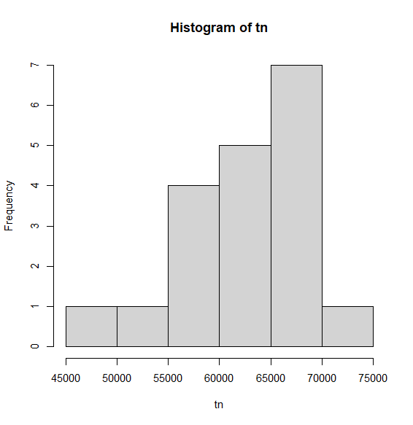

Figure 5.5 histogram (State Tamilnadu)
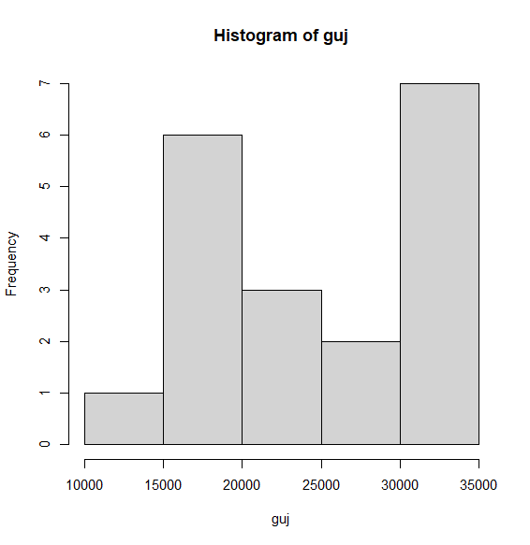
Figure 5.6 histogram (State Gujrat )

Histogram Interpretation
- The histogram of Gujarat shows moderate spread with values concentrated around 20,000–30,000.
- The histogram of Tamil Nadu shows higher values concentrated around 55,000–70,000.
Interpretation:
Tamil Nadu consistently exhibits higher accident counts compared to Gujarat.

Boxplot Interpretation
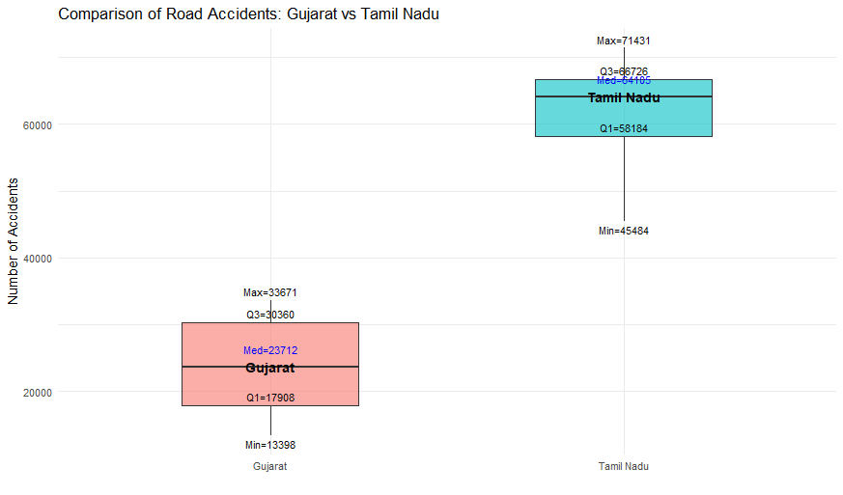

Figure 5.7 Box plot of Gujrat vs Tamilnadu
- Median of Tamil Nadu is significantly higher than Gujarat
- Gujarat shows lower central tendency
- Spread is relatively comparable but shifted upward for Tamil Nadu
Interpretation:
The boxplot clearly indicates a substantial difference in central tendency, suggesting higher accident levels in Tamil Nadu.
3. Assumption Checking (Normality)
To apply the independent t-test, normality of both samples was tested using the Shapiro–Wilk test.

Results:
State | p-value |  | Decision
Gujarat | 0.096 |  | Normal
Tamil Nadu | 0.156 |  | Normal

Interpretation:
Since p-values for both states are greater than 0.05, we fail to reject the null hypothesis of normality. Therefore, the assumption of normality is satisfied.
4. Selection of Statistical Test
Since:
- Data is approximately normal
- Two independent groups
Independent Two-Sample t-test was used.
5. Hypotheses
$$H_{0}:μ_{Gujarat}=μ_{Tamil Nadu} \\ H_{1}:μ_{Gujarat}≠μ_{Tamil Nadu}$$
6. Test Results
- t-statistic = -17.589
- Degrees of freedom = 36
- p-value < 2.2 × 10⁻¹⁶
95% Confidence Interval:
(−42426.74, −33654.20)
The entire confidence interval is negative, which indicates that the mean number of accidents in Gujarat is significantly lower than in Tamil Nadu. Since zero is not included in the interval, this provides strong evidence that a true difference exists between the two states.

Sample Means:
- Gujarat = 24,125.42
- Tamil Nadu = 62,165.89
7. Decision
$$p<0.05⇒Reject H_{0}$$
There is a statistically significant difference between the two states.

8. Interpretation of Results
The results indicate that the mean number of road accidents in Tamil Nadu is significantly higher than in Gujarat. The negative confidence interval further confirms that Gujarat’s mean is substantially lower.
9. Practical Significance
The difference between the two states is not only statistically significant but also practically large, with Tamil Nadu experiencing nearly 2.5 times more accidents on average compared to Gujarat.
10. Final Conclusion
The analysis clearly demonstrates that Tamil Nadu has a significantly higher road accident burden compared to Gujarat. This suggests the presence of regional differences in factors such as traffic density, urbanization, and road infrastructure.

Comparison of road accidents: gujarat vs karnataka
1. Objective
The objective is to compare the accident distribution between Gujarat and Karnataka to determine whether a statistically significant difference exists between the two states.
2. Exploratory Data Analysis
Histogram Interpretation
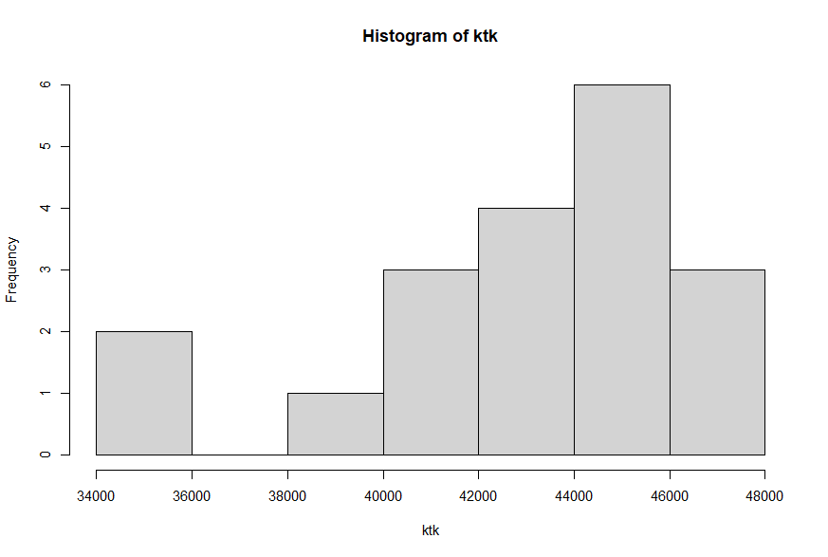
Figure 5.8 Histogram of Karnataka
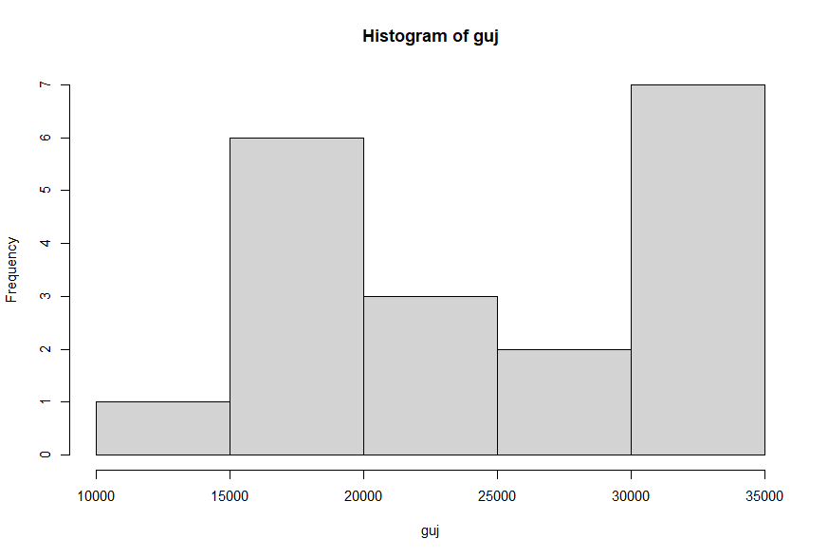
Figure 5.9 Histogram of Gujrat

Gujarat (guj):
  - Values concentrated around 15,000–30,000
  - Moderate spread
Karnataka (ktk):
  - Values concentrated around 40,000–47,000
  - Higher central tendency

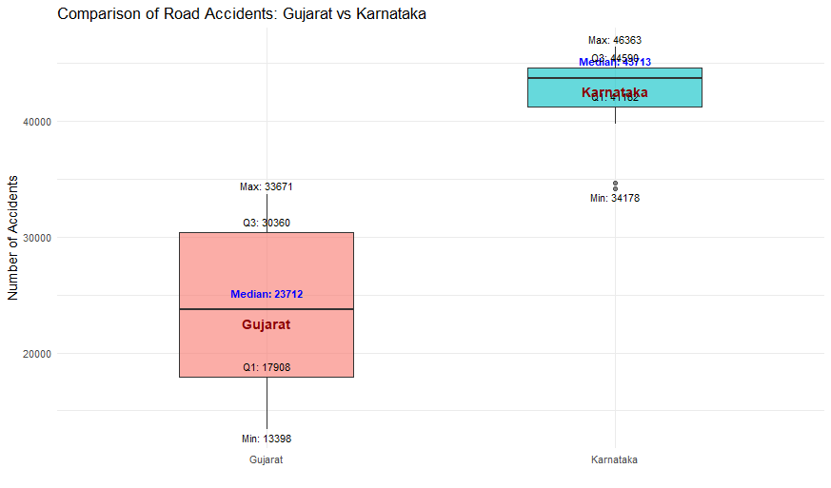
Figure 5.10 Box plot of Gujrat vs Karnatka
Interpretation:
Karnataka consistently shows higher accident counts compared to Gujarat.
Boxplot Interpretation
- Karnataka has a much higher median
- Gujarat has lower values across all quartiles
- Clear separation between two distributions
Interpretation:
There is a strong visible difference between the two states, with Karnataka having significantly higher accident levels.

3. Assumption Checking (Normality)
Shapiro–Wilk test results:
State | p-value | Decision
Gujarat | 0.096 | Normal
Karnataka | 0.0048 | Not Normal

Interpretation:
Since Karnataka data violates the normality assumption (p < 0.05), the independent t-test is not appropriate. Therefore, a non-parametric test is required.
4. Selection of Test
Based on violation of normality:
The Wilcoxon Rank-Sum Test was used to compare the two independent samples.
5. Hypotheses
$$H_{0}:Median accidents in Gujarat = Karnataka \\ H_{1}:Median accidents are different$$6. Test Results
- Test statistic (W) = 0
- p-value = 5.658 × 10⁻¹¹
7. Decision
$$p<0.05⇒Reject H_{0}$$
There is a statistically significant difference between the two states.
8. Interpretation of Results
The Wilcoxon test indicates that accident counts in Karnataka are significantly higher than in Gujarat. The extremely small p-value confirms that this difference is not due to random variation.
9. Final Conclusion
The analysis clearly shows that Karnataka has significantly higher road accident counts compared to Gujarat. Both statistical testing and graphical analysis support this conclusion, highlighting strong regional variation in accident patterns.

5.9 Time Series Forecasting
To forecast the total number of road accidents in India, a time series approach was adopted. Initially, the stationarity of the series was examined using the Augmented Dickey-Fuller (ADF) test. The results indicated that the series is non-stationary and exhibits a clear trend.
Since the data consists of annual observations with no evident seasonal pattern, Holt’s Linear Trend Model was selected. This model is suitable for time series data characterized by a trend but lacking seasonality.
Furthermore, due to the limited number of observations and absence of strong autocorrelation structure, more complex models such as ARIMA were not preferred.
2. Stationarity Test (ADF Test)
Hypotheses:
$$H_{0}:Series is non-stationary \\ H_{1}:Series is stationary$$
Results:
- ADF Statistic = -2.1821
- p-value = 0.503
Interpretation:
Since the p-value exceeds the 0.05 significance level, we fail to reject the null hypothesis. This confirms that the series is non-stationary, primarily due to the presence of a trend component.
3. Model Specification (Holt’s Linear Trend Model)
Holt’s model decomposes the time series into level and trend components:
$$\begin{matrix}L_{t} & =αY_{t}+(1-α)(L_{t-1}+T_{t-1}) \\ T_{t} & =β(L_{t}-L_{t-1})+(1-β)T_{t-1}\end{matrix}$$
Where:
- $L_{t}$= level component
- $T_{t}$= trend component
- $α$= smoothing parameter for level
- $β$= smoothing parameter for trend
4. Model Output and Interpretation
Smoothing Parameters:
- $α=0.9999$
- $β=0.0001$
Interpretation:
The value of $α$being close to 1 indicates that the model places strong emphasis on recent observations, making it highly responsive to recent changes in accident data. This is particularly important in capturing sudden variations such as the sharp decline observed in 2020.
The very small value of $β$suggests that the trend component is relatively stable and does not change rapidly over time.
Model Fit Statistics:
- AIC = 457.45
- RMSE = 29,813.77
- MAE = 21,410.13
- MAPE = 4.85%
Interpretation:
The relatively low MAPE value indicates that the model provides a good fit to the data. The error measures (RMSE and MAE) are reasonable given the large scale of accident counts.

5. Forecast Results
Table 5.9 Forcasting from 2024 to 2026
Year | Point Forecast | Lo 80 | Hi 80 | Lo 95 | Hi 95
2024 | 4,83,834.80 | 4,40,833.20 | 5,26,836.30 | 4,18,069.60 | 5,49,600.00
2025 | 4,87,088.20 | 4,26,274.80 | 5,47,901.50 | 3,94,082.10 | 5,80,094.20
2026 | 4,90,341.60 | 4,15,858.20 | 5,64,824.90 | 3,76,429.10 | 6,04,254.00
2027 | 4,93,595.00 | 4,07,585.40 | 5,79,604.50 | 3,62,054.70 | 6,25,135.20
2028 | 4,96,848.30 | 4,00,682.40 | 5,93,014.30 | 3,49,775.30 | 6,43,921.40

Interpretation:
The forecasts indicate a gradual upward trend in the number of road accidents over the next five years, suggesting that accident levels are expected to continue increasing if current conditions persist.
6. Confidence Interval Interpretation
For example (2024):
- 80% CI: (440,833 , 526,836)
- 95% CI: (418,069 , 549,600)
Interpretation:
The confidence intervals widen as the forecast horizon increases, indicating growing uncertainty in future predictions. This is a common characteristic of time series models. It also suggests that short-term forecasts are more reliable than long-term projections.

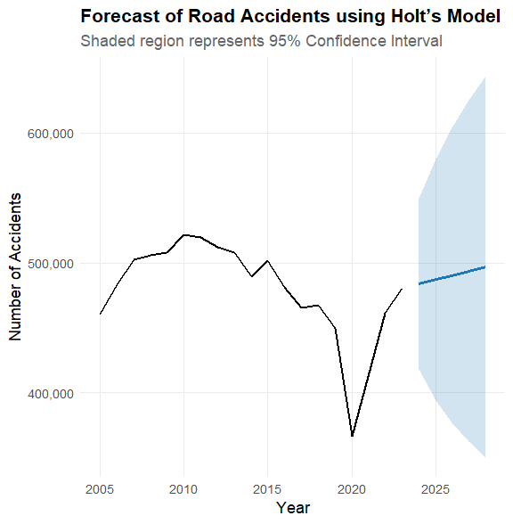
Figure 5.11 Forcasting Plot
The forecast plot shows a steady upward trajectory in accident counts. The shaded regions represent confidence intervals, which widen over time, reflecting increased uncertainty in long-term forecasts. While the general trend is upward, the exact values may vary due to external factors.

OVERALL CONCLUSION
This study provides a comprehensive statistical analysis of road accidents in India using data from 2005 to 2023. The analysis integrates trend analysis, growth rate evaluation, severity and survival assessment, regression modeling, and time series forecasting to understand accident patterns and future risks.
The results show that while the total number of accidents has fluctuated over time, fatalities have consistently increased, indicating that accidents are becoming more severe. This is further supported by the increasing severity rate and declining survival rate, suggesting a higher probability of death per accident.
Overspeeding has emerged as the most significant contributing factor, accounting for nearly 70–72% of total accidents. The Negative Binomial regression model confirmed a statistically significant upward trend in overspeeding-related accidents, with approximately 1.66% annual increase. Although this increase appears small, it translates into thousands of additional accidents due to the large scale of total accident counts.
The analysis of road characteristics revealed that straight roads exhibit the highest accident incidence, primarily due to higher speed and traffic exposure. In contrast, roads with constraints such as potholes, steep gradients, and culverts show lower accident counts, indicating that reduced speed plays a critical role in accident occurrence.
The comparison between Poisson and Negative Binomial models demonstrated the presence of overdispersion in the data. The Negative Binomial model provided a significantly better fit, making it the most appropriate model for analyzing accident counts.
Time series forecasting using Holt’s linear trend model indicated that road accidents are expected to increase gradually in the coming years. The widening confidence intervals highlight increasing uncertainty, but the overall upward trend suggests that accident levels will continue to rise if current conditions persist.
Hypothesis testing further revealed significant regional differences in accident patterns, with states like Tamil Nadu and Karnataka showing substantially higher accident counts compared to Gujarat. This highlights the importance of region-specific analysis and policy interventions.

RECOMMENDATIONS
Based on the findings of the study, the following measures are suggested to improve road safety:
1. Control of Overspeeding
Overspeeding is the major cause of accidents. Strict enforcement of speed limits through cameras, penalties, and monitoring systems is essential.
2. Improve Safety on High-Risk Roads
Straight roads show higher accident rates due to high speed. Installing warning signs, speed control measures, and proper road markings can reduce accidents.
3. Strengthen Emergency Services
Improving ambulance response time and trauma care facilities can reduce fatalities and increase survival rates.
4. State-Specific Policies
Accident patterns vary across states. High-risk states should receive focused attention and targeted interventions.
5. Promote Awareness
Public awareness about safe driving, helmet use, and seatbelts should be increased to reduce risky behavior.

REFERENCES
- Ministry of Road Transport and Highways. (2008). Road Accidents in India 2008. Government of India.
- Ministry of Road Transport and Highways. (2009). Road Accidents in India 2009. Government of India.
- Ministry of Road Transport and Highways. (2010). Road Accidents in India 2010. Government of India.
- Ministry of Road Transport and Highways. (2011). Road Accidents in India 2011. Government of India.
- Ministry of Road Transport and Highways. (2012). Road Accidents in India 2012. Government of India.
- Ministry of Road Transport and Highways. (2013). Road Accidents in India 2013. Government of India.
- Ministry of Road Transport and Highways. (2014). Road Accidents in India 2014. Government of India.
- Ministry of Road Transport and Highways. (2015). Road Accidents in India 2015. Government of India.
- Ministry of Road Transport and Highways. (2016). Road Accidents in India 2016. Government of India.
- Ministry of Road Transport and Highways. (2017). Road Accidents in India 2017. Government of India.
- Ministry of Road Transport and Highways. (2018). Road Accidents in India 2018. Government of India.
- Ministry of Road Transport and Highways. (2019). Road Accidents in India 2019. Government of India.
- Ministry of Road Transport and Highways. (2020). Road Accidents in India 2020. Government of India.
- Ministry of Road Transport and Highways. (2021). Road Accidents in India 2021. Government of India.
- Ministry of Road Transport and Highways. (2022). Road Accidents in India 2022. Government of India.
- Ministry of Road Transport and Highways. (2023). Road Accidents in India 2023. Government of India.
- Damodar N. Gujarati, & Dawn C. Porter. (2009). Basic Econometrics (5th ed.). McGraw-Hill Education.
- Peter McCullagh, & John A. Nelder. (1989). Generalized Linear Models (2nd ed.). Chapman and Hall.

